Prof.dr. Lejla Turčilo

BEING DECENT IN POLITICS:
Brief Remarks on Ethical and Rational Political Communication and its Importance for Political Integrity and Democracy

Sarajevo, 2022.
C o n t e n t

Introduction: Force of Argument VS Argument of Force: Why Does the Culture of Dialogue and Argument- based Debate Still Matter?

Key Terms and Concepts of Decent Political Communication and its Opposites
- Political Communication: Election Campaigns and Decision Making and the Importance of Building Quality Relations with Supporters and Opponents
- Culture of Dialogue and Its Importance for Democracy

DOs and DON’Ts : Key Things to Bear in Mind in Terms of Responsibility for Public Dialogue
- Tips and Tricks for Political Actors

Reading List

About the Author

Introduction: Force of Argument VS Argument of Force: Why Does the Culture of Dialogue and Argument- based Debate Still Matter?

“The aim of the argument should not be victory, but progress.”
Karl Popper

Political communication is an integrative and inevitable part of every activity in the political arena and the public sphere. It is part of both political decision-making and presenting those decisions to whom they may concern. In that context, it is clear that how one communicates in the public space and political sphere is crucial, since all the political decisions need to be based on high-quality information received through communication process, but also need to be explained and receive support from citizens.
There are many definitions of political communication and many ways to explain political processes and the role of communication in them, but they all have in common the following:
- Communication is an inevitable part of all political processes
- Political communication has a strict rules that need to be followed in order to make political arena a safe and open space for an argument-based debate
- Rules of political communication apply to all its actors, including politicians and political parties, government and non-governmental organizations, media and other members of civil society, interest groups and citizens.
Quite often, actors in the political arena see political communication strictly as presentation of their ideas, views and standpoints and confronting them with the ideas, views and standpoints of their political opponents. In that regard, they see political communication strictly as “selling” the impression and “buying” the consent. In other, words, they see the communication as a tool for self-promotion and a tool for gaining support. This is very narrow and to certain extent wrong perception of the importance of communication in politics. In a wider sense, we may say that the political communication in democracy servers the purpose of establishing mutual understanding and exchange of views on how society should function between those who make decisions and those that are affected by such decisions.
Brian McNair (2018:23) in this context says that the purposeful communication about politics incorporates:
- All forms of communication undertaken by politicians and other political actors for the purpose of achieving specific objectives.
- Communication addressed to these actors by non-politicians such as voters and newspaper columnists.
- Communication about these actors and their activities, as contained in news reports, editorials, and other forms of media discussion of politics.
There are several aspects that need to be taken into consideration when it comes to political communication and its role in democratic society:
- Political communication is closely related to political integrity
- Its main role in society is to connect all relevant actors, to provide them with an opportunity to present their arguments and to make them gain the consensus on what is the best solution for issues and/or problems in society.
When we say that political communication is closely related to political integrity, that means that everyone who participates in the political processes need to ensure that his/her deeds match his/her words.
OECD (2017) defines integrity as:
the consistent alignment of, and adherence to, shared ethical values, principles and norms for upholding and prioritizing the public interest over private interests in the public sector.
In that regard, political communication based on the principles of integrity can be defined as:
the consistent and truthful communication about the key issues in the public sector, focused on the public interest and based on the ethical principles and norms.
In general, political communication is an action of communicative exchange between formal decision-making body/ies and the public. Decision-making bodies do have political power in certain society in certain moment of time, but that political power is derived from legitimacy given to them by the public. The public holds them accountable and the communication between them and the public serves the purpose of gaining support and legitimacy as much as the purpose of obtaining or preserving the political power.

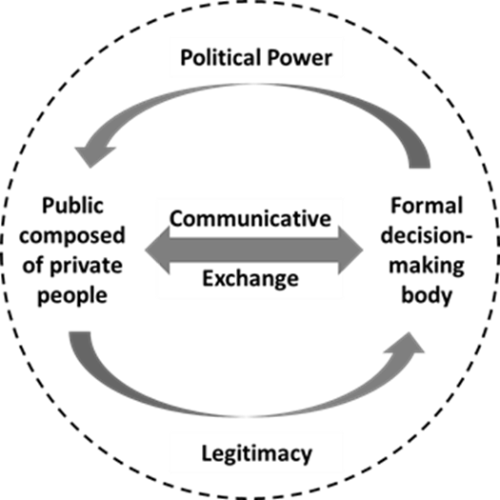
Graph 1: Communicative exchange in politics (OECD)

All actors in the political arena are responsible for establishing a communicative exchange which has a purpose and the meaning. In order to do so, the main element of their messages exchanged in the public space, or the key component of political communication is (or it should be) “His Excellency the Argument”.
Force of argument (instead of the quite often present in political communication: the argument of the force) is a pre-condition for a successful and meaningful political communication.
Argument-based debate also guarantees that political actors have the public integrity, since the theory and the practice of political communication teach us that only those actors whose work is not in the public interest (meaning that they mis/use their political power to achieve some particular interest) use the argument of the force and indecent communication to fuel the divisions and chaos in society, so that the public is prevented from seeing that the public interest is not in their focus and that the political power is abused.
In this context, we may say that the argument- based debate is a top priority in political communication, for two main reasons:
- It assures citizens that the government is working in their interest, not just for the select few, and is vital for the economic prosperity and well-being of society as a whole
- It assures that public integrity matters to citizens, not only politicians.

Key Terms and Concepts of Decent Political Communication and its Opposites

Political Communication: Election Campaigns and Decision Making and the Importance of Building Quality Relations with Supporters and Opponents

What does a decent political communication mean? Shouldn’t all political communication and in general, communication in the public space be decent? And how does that affect public life and democracy?
Political communication always happens in a certain political context, determined by social, economic and political conditions in a community. It affects the public/people at three levels:
- Their emotions (how they feel about certain political issue, event or situation in which they are, as well as political subjects that approach them);
- Their attitudes (what kind of rational relations they establish towards the content of the messages they receive about certain issues, as well as towards the subjects that send such messages);
- Their behavior (how, under the influence of certain political messages, they behave in a certain moment and/or situation).
In this context, it is crucial to understand that the way political subjects communicate in the public sphere impacts the way people behave in society. This is why political actors are not only responsible for messages they send, but also for all that such messages cause in society.
Indecent communication usually provokes bad feelings (mainly fear and anger), irrational relations towards political reality (in which people tend not to see things clearly) and behavior which usually ends up in conflict. Indecent communication, thus, is a threat to democracy and society, since it easily escalates in violence and crisis.
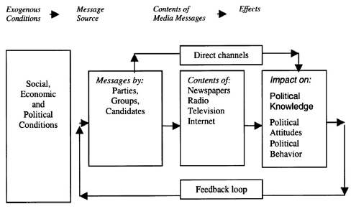
Graph: Elements and flow of political communication (source: http://political-science.iresearchnet.com/political-communication/)

Decent communication in politics means responsible communication, with full awareness of all the consequences it may cause. It is an open, honest, civilized, argument-based political dialogue with all political stakeholders in a society.
If we divide political communication in two of its segments:
- Communication during the pre-election campaign
- Communication in between elections
Then a decent political communication means:
- Establishing respectful and argument-based public debate with colleagues from the political party and/or other parties in the same part of the political spectrum, as well as their supporters, but also with political opponents and their supporters = before one is elected;
- Those who gave support in the form of voting for certain political option, but also those who did not = once one is elected.
It is, of course, much easier to communicate with those who share the same values or express support to one’s ideas and views, but the problem usually arises in communication with opponents and those who disagree or have different views and ideas. This is why we say that one of the preconditions of decent and high-quality political communication is that political subject accepts the fact that there are those who will never support them or share their values.
“I may not be right, and you might” is the right attitude towards opponents in the public debates and discussions.
There are several other advices on how to obtain a decent political discourse in a society:
- Information sharing is crucial – it is important that a communication is about sharing information that might help citizens (since citizens should always be in focus of every communicative act in politics) and not about defamation of opponents and verbal fights with them;
- Embracing conflict is important - confrontation is actually good for the society. It contributes to dynamic of change, it helps manifesting diverse expectations, intentions and ideas in society. Avoiding confrontation is not always necessary, however when in confrontation with opponents every political actor must be respectful and responsible for controlling that the conflict does not exceed “the red line” and become a fight.
- Listening to other people’s arguments is as important as presenting those one has – this, of course, means listening with the main aim to understand the standpoints of opponents, and not only to respond to them.
- It is not necessary that every communication act ends with mutual agreement, but it is necessary to ends with mutual understanding.
If we would like to put the rules of decent political communication into simple words, we would say that decent political communication is:
- Transparent – enables citizens to see clearly that their political representatives have nothing to hide;
- Accountable – enables citizens to see clearly that their political representatives’ deeds match their words;
- Inclusive - enables citizens to see clearly that their political representatives provide enough public space for everyone voices to be heard;
- Responsive - enables citizens to see clearly that their political representatives not only care about sending messages to them, but also respond to their messages and their needs;
- Participatory - enables citizens to see clearly that their political representatives include them in all decision-making processes and communication about them;
- Consensus oriented - enables citizens to see clearly that decisions are not made “behind closed doors”, but after public consultations with them;
- Effective - enables citizens to see clearly that their political representatives communicate with an aim to gain enough information, ideas and views that would help them be effective in their work;
- Efficient - enables citizens to see clearly that their political representatives do not waste time and resources on irrelevant things, but are efficient in explaining political issues, political decisions and political processes;
- Respectful - enables citizens to see clearly that their political representatives respect all those included in the communication process, not only those that support them and agree with them;
- Proof – based - enables citizens to see clearly that their political representatives can and do prove that they work in the public interest.
These are all also ground rules of good governance, so it is clear that decent communication in politics is not only a matter of communication form and communication style, but rather a matter of political integrity.

Culture of Dialogue and Its Importance for Democracy
The best way to solve problems and to fight against war is through dialogue”
Malala Yousafzai
Politics is not about getting in power and staying in power for the sake of individual interest. Politics is about making decisions which are in the public interest and that inevitably includes discussing these decisions before and after they are made with all members of society.
Good governance and good politicians are focused rather on policy than on politics. Policy-making, as a plan of action agreed or chosen by political actor needs a consent of all stakeholders, above all of the general public. That is why we say that the public dialogue is crucial for all aspects of policy-making.
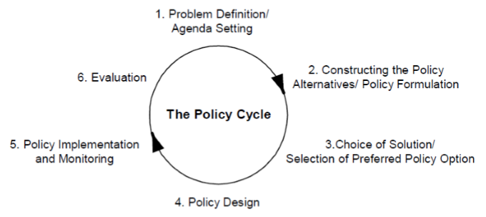
Graph: Policy cycle (Young and Quinn, 2002).

As shown in the graph, decision-making and/or policy creation is a set of steps that need to be undertaken in order to solve certain issues and/or problem in the society. However, many of these problems do not even get the public attention before they are presented in the public sphere by media or influential individuals. This is the reason why agenda setting function, that is putting certain issues on the agenda and in the public spotlight, is one of the most important media functions. What sort of issues and unsolved problems will be put on the agenda is something that needs to be publically debated. Once these issues are defined as important and once they become priority for the public, several alternatives and solutions need to be presented (constructing the policy), with the main aim to choose the one which serves the society the best. In the process of presenting policy alternatives and selecting preferred one, public dialogue is a vital for the success. Once policy is designed and during its implementation various voices will be heard, both agreeing and disagreeing with it, and political actors in charge need to be ready to hear and accept all alternative and dissonant voices. Accepting constructive critics is also crucial in the phase of evaluation of the implemented policy, so that decision-makers can see more clearly what did and what did not go well in the process.
It is obvious that, when we look at politics as serving the public interest and not (only) as gaining or preserving the power, that makes politics a collaborative work. But, as Ken Cloke points: “working collaboratively with those who are different, those we dislike, those with whom we disagree, even those whose actions we find repellent, requires higher order listening, dialogue, negotiation, and conflict resolution skills.”.
As Cloke points, politics and political communication needs to be based on the public dialogue, in which people engage based on their already formed views, ideas, experiences and arguments. It is not possible to expect that they will change them fully in the process, so the public dialogue is about finding smallest common denominator, which helps overcoming differences for the sake of solving mutual problems.
”In other, words, it is possible to view political statements not as adversarial, win/lose, true or false propositions (which is how they are generally presented), but rather as distorted indicators of experience and perception, personal stories of pain and injustice, declarations of disagreement or desire, appeals for solidarity and support, requests for improvement, and hopes for the future, none of which are necessarily mutually exclusive, in that they do not require other truths to be false in order to be true themselves. This is the essence of interest-based approaches to conflict resolution, which routinely reframe positions as interests, accusations as requests, and criticisms as invitations into dialogue, and improved communication, connection and relationship.”
(https://www.kencloke.com/why-dialogue-in-politics-1)
Cloke therefore defines political conflict as consisting of three essential elements:
- Diversity: In the first place, there must be two or more distinct individuals or groups of people, each with diverse beliefs, ideas, opinions, needs, and interests. Without this, there cannot be conflict.
- Inequality: In the second place, there must be an inequality in power between these individuals or groups, reflecting their ability to implement their diverse beliefs, ideas, opinions, etc. Without this, the conflict will not take a political form.
- Adversarial, win/lose process: In the third place, there must be an adversarial, win/lose process for problem solving or decision-making that pits diverse individuals and groups against each other, allowing only one to win. Without this, the conflict will not become polarizing or chronic.
In this context, it is important to understand that political conflict is part of the political communication. However, the way conflict is handled in the political arena makes a difference between democratic and non-democratic political communication

NON-DEMOCRATIC POLITICAL COMMUNICATION
- Not respective
- Irrational
- Inflammatory rhetoric
- Appeal to emotions

DEMOCRATIC POLITICAL COMMUNICATION
- Respective
- Rational
- Argument - based
- Appeal to cognitive

Some of the key problems nowadays, when it comes to public dialogue in political arena, include the following:
- No communication at all – everyone simply trying to put their messages out there, without any interest to hear someone else;
- I may not be right, but you might! – This is very rarely the starting point in the public dialogue;
- Public interest is secondary to the struggle for power, which makes political communication harsh and indecent.
- Public interest is not interesting for the public any more, which is why political actors attract the attention of the audience by scandals, harsh language, hate speech and other indecent narratives.
In spite of these (and other) dialogue is the best way to resolve problems. It is the only way to reach decisions that are acceptable to everybody. Dialogue is the primary means of avoiding, or resolving, conflict. What separates democracy from other political philosophies is the principle and practice of solving differences first and foremost through dialogue.
Dialogue needs to be inclusive of different points of view. A lack of inclusive dialogue generates frustration and, over time, rejection and rebellion. "Dialogue" and "inclusiveness" are part of the essence of a culture of democracy. They are qualities that need to be nurtured and demonstrated in everyday life. Educating people about the principles of democracy is vital to developing democratic culture. This is an ongoing process. Respect for the rule of law, and respect for the other, are fundamental notions of democracy that apply equally to all people, whatever their position in society.
http://archive.ipu.org/idd/dialogue.htm
So, how to ensure that your political communication style contributes to public dialogue? Kerry Patterson has five basic rules:
- Start with desire to learn not win - it is not possible to expect that everyone will accept one’s points of view and ideas. That is not even the point nor the purpose of public dialogue. The point is to establish mutual understanding of people with different views and to make sure that everyone has a chance to be heard. In that regard, it is important to be able to learn why certain people think and behave in certain way and then to define the best ways to communicate your messages to them. Some authors advise you to “earn the right to share your views by allowing others to share theirs. Enter the conversation with the sincere desire to learn about others; otherwise you’ll just end up haranguing them with your view and fail miserably.”
- View others as rational, not wrong – people tend to believe what they believe because they operate with different sets of information. This is why it is important in political communication not to think about others as wrong-thinkers, but rather to think about reasons which made them believe something and to try to use arguments to change their beliefs.
It’s interesting to watch politicians talk with one another. Perhaps the fact that they’re on TV or the radio is distorting their normal tactics, but whatever the reason, they’re looking more and more like Jerry Springer guests than political pundits. They don’t just disagree with the other person; they’re disgusted that the other person could hold such an insane view. The insulting language follows. The sneers, the rolling eyes, the looks of dismay all add up to one message—you’re an idiot.
The truth is, any topic that has divided the nation or your community isn’t divided along the lines of “me and all right-thinking people” and “all of those idiots out there who disagree with us.” Like it or not, the other people are reasonable, rational, and generally decent. They hold a different view largely because they hold different information. Find a way to get the information out on the table and it’s likely people will resolve their differences.
Now, this reasonable approach isn’t nearly as fun as thinking that others are morons. It doesn’t condone our actions to attack them or make fun of them or be disgusted by them. It forces us to talk to them. And as a result, it is far more effective. If you enter a conversation with the view that others are reasonable, rational, and decent, the next step follows naturally.
https://vitalmagonline.com/5-tips-to-talk-politics-with-friends-and-family-and-still-have-some-left/
- Listen, do not just wait to talk - Listening, as Patterson says, consists of the sincere act of trying to understand the other person’s point of view. It starts with attending to the words they say and the concepts they share. It continues as one tries to make sense of their comments rather than discredit them. And to truly listen, one should be looking for the truth in what the other person says—trying to find a common understanding.it.
- Use tentative language – although we have said that decent, rational and argument-based political communication is more a matter of ethics rather than style, the way language is used is an important aspect of it. In order to establish healthy dialogue, especially with the opponents, the language must not be forceful and harsh, but rather persuasive and rational. It has to show respect, not necessarily to those who are one’s opponents, but to the public that is also engaged in the dialogue (even if the level of its engagement is only following the conversation). And it has to show openness to listen to counter opinions and confront them with clear arguments, not hard rhetoric.
- Invite opposing views - But, be sincere in the quest to hear new ideas and contrasting opinions. That not only shows readiness to listen, but also a confidence and readiness to challenge your own ideas and thoughts.

Create a climate where making a point is nothing more than that. Expressing an idea doesn’t mean you’ve tattooed it to your thigh. You’re not married to your point of view. It’s an idea and ideas should be examined from all sides. Now, this doesn’t mean you can’t hold an opinion, just that you’re willing to share what you currently think and then hear what others have to say, particularly if it’s different.
https://vitalmagonline.com/5-tips-to-talk-politics-with-friends-and-family-and-still-have-some-left/

DOs and DON’Ts : Key Things to Bear in Mind in Terms of Responsibility for Public Dialogue

When it comes to responsibility for public dialogue, it is important to bear in mind that public dialogue contributes not only to the reputation and impression related to political subject (elected official, politician or political party), but also to the quality of public life and democracy in society. In that regard, political communication is a strategic communication, with some important things to bear in mind:
- It is important to use different tools (such as direct communication, media, social networks etc.) for not only spreading the messages, but also for framing a communication, so that it is outome/result-oriented, decent and respectful.
- It is important to understand that participating in public dialogue is not just about reacting and responding, but rather about listening and understanding and then tailoring the messages focused on finding solutions, not expanding the problems.
- Creating a good public image is important, so political communication should serve that purpose as well. The public is more prone to those political subjects that are respectful and decent, so such communication style contributes to long-term reputation.
- Reaching a diverse audience is possible only by respectful communication, which makes everyone’s voices heard and respected, everyone’s perspectives understood and common solution to mutual problems derived from fruitful debate.
- Making a positive impact in the society should be a main general goal of all political subjects. That is possible only if they are ready to reach a consensus with others and focus on public interest.
- Long-term impact of decent communication is a permanent benefit – sometimes it seems like everyone is using harsh language and indecent communication and it works. However, that might be the way to achieve short-term goals. In the long run, decent and high-quality strategic communication is always better road to success.
If we consider the political communication as a strategic one, then there are five main tasks for everyone who is planning on how to communicate in the public space:
- Identify the Audience: To WHOM do you need to communicate? ... Is it just your supporters (which then makes less of a chance for a conflict, for example, since your basic views and attitudes are similar if not the same) or opponents (with higher chance of conflict due to differences in views and competitiveness). Here it is important to mention that, although messages should be tailored differently for different groups of the audience, the ground rules of decency, respectfulness, public interest – orientation and fact-based messages stay the same.
- Determine Goals and Objectives: WHY communicate? ... Sometimes the goal is to attract the attention of the audience, to make people directly support certain action(s) (for example, that is the case in the pre-election campaign) and sometimes the objective is to present certain ideas and test them in the public space. Also, the goal might be to respond to some messages that have already been spread by opponents. In any case, it is important to tailor the messages so that they reflect what we believe in and what we do, as well as to give to people the reason to believe in our words and our actions. Even in the conflict, the goal should never be to diminish or compromise any other stakeholder in the political sphere, but rather to express our difference and advantages compared to them.
- Develop Key Messages: WHAT do you need to communicate? ... These messages should reflect the identity and the work of the political subject and should make people confident that those subjects represent the interests of the public and work on its behalf. It is important to always have that in mind. Political communication is about making people believe in the work of political subjects and in that sense key messages should reflect good practices.
- Develop Tactical Plan: HOW will you communicate, to whom and when? … This is why we say that all political communication is strategic and it has to be well planned. It is very important to have a clear tactical plan for all aspects of political communication, which makes it coherent and trustful and at the same time prevents political subjects from being involved in narratives imposed by someone else, especially ones that are indecent and disrespectful.
- Identify measure of evaluation: HOW will you know if you were successful? … Every communication process is also a chance for learning, improving and growing. Evaluation post festum is an important part of political communication, which enables political subjects to more clearly see their good and weak points and to improve in the future.

Strategic political communication is part of strategic planning in politics, meaning that information should be considered across the entirety of strategic thinking, not as separate instrument. This is due to the fact that there is an informational dimension to every aspect of politics.

Meaningful and goal-oriented political communication is always about developing a partnership with various stakeholders!

How to do so?

First, by understanding the information environment! That means understanding the dynamics of information and communication. The information environment is not a place where activity takes place or a physical domain with boundaries such as land, sea or air.
Information environment is a conceptual space which helps to describe how the public perceives the world, deduces meaning from it and how that affects attitudes, decision-making and behavior.
Understanding the information environment therefore requires a persistent, systematic analysis of relevant actors and audiences, plus identification of the different methods and narratives used by adversaries.

Bear in mind some important challenges:
- People consider their perception as truth – your communication influences that perception
- There are new global challenges in communication, including online communication, that need to be tackled (disinformation and hate speech, for example)
- There is a polarized communication globally nowadays
- At the same time, all information environments are always both local and global

Who are the key stakeholders?
- Governments
- Other political actors
- Civil society
- Economic sector
- General public

Not all of them will necessarily have positive attitude. However, that only enhances your need to have a good communication, since you need to make sure that the dominant narrative is in your favor.
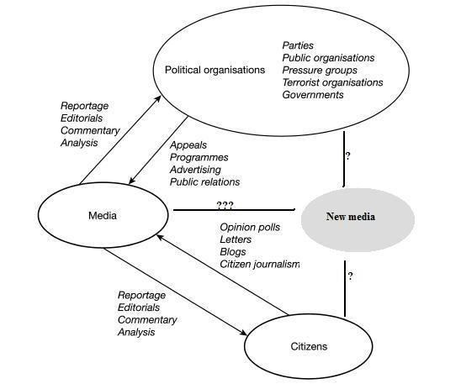

Graph: Political arena and actors of political communication nowadays (McNair, 2018: 28)

Key principles of good and decent political communication, put in several simple terms, are:
- What you say must match what you do;
- All activities must be based on values;
- Credibility and trust are vital resources;
- Communication is a collective and integrated effort (not only job of communication specialists);
- Focus must be on efforts and outcomes;
- All messages must go in line with each other.

It is also important to remember that political communication is narrative-based.
A narrative can be defined in simple terms as: what we stand for and what we believe in.
It is crucial that all communication is in accordance to defined narrative.

Tips and Tricks for Political Actors:
- Follow the 3C Rule: Consistency, Credibility and Coherence – that should be the fundamental base of every political communication;
- Listen to the audience you are targeting - and always make sure that you understand their needs and expectations;
- Use dynamic communication style, but never ever cross the line of decent communication
- React quickly and swiftly to other actors’ messages, but never let them drag you into their narratives – There will be situations in which something happens and distracts you from spreading your messages, for example, bad news, changes in stakeholder expectations and perceptions, sudden rumors, but also the influence of other actors who draw attention to their messages. In short, everything distracts from the normal course of events. This must not impact your decent and fact-based communication and change it into its opposite.
- Stay close to citizens, their concerns, expectations and views. Be authentic and have empathy
In general, we may say that there is no good political action without good political communication. And vice versa.

Reading List

- Azmanova, A. (2012.) The Scandal of Reason: A Critical Theory of Political Judgment. Columbia University Press
- Keith, W. and Lundberg, Ch. (2008), The Essential Guide to Rhetoric. Bedford/St Martins Publishers
- Lilleker, Darren G. (2007) Key Concepts in Political Communication, NY: SAGE Publications
- Kenski K. Jamieson K. H. (2017). The Oxford Handbook of Political Communication. Oxford University Press
- McNair B. (2018). An Introduction to Political Communication. NY: Routledge.
- Semetko H. A., Scammell M. (2012). The SAGE Handbook of Political Communication. NY: SAGE Publication LTD
- http://political-science.iresearchnet.com/political-communication/
- https://www.kencloke.com/why-dialogue-in-politics-1
- https://vitalmagonline.com/5-tips-to-talk-politics-with-friends-and-family-and-still-have-some-left/

About the Author
Dr. sci. Lejla Turčilo is a full time professor at the Department of Communication Science/ Journalism at the Faculty of Political Science, University of Sarajevo, Bosnia-Herzegovina, where she teaches courses in Media Theory, TV Journalism, Online Journalism and Media and Politics at the undergraduate and master's degree level and Creation of New Public by PR and Online Media at the Doctoral Study. She has published four authored books, six co-authored books, as well as one manual and five research publications. She has published more than forty scientific and professional papers in Bosnia and Herzegovina and abroad. She is the head of the Center for Lifelong Learning at the Faculty of Political Sciences of the University of Sarajevo and the head of the Department of Communication Science/ Journalism. Her field of interest is online communication, political communication, intercultural communication, media literacy and media freedom.

